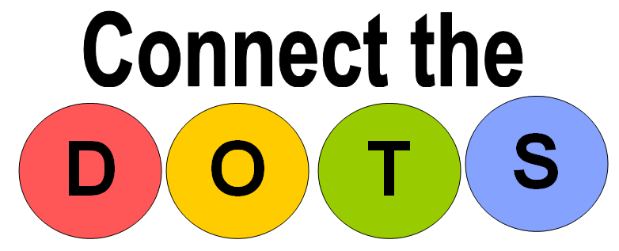
SMPEM 111
August 2013
Angiotensin Converting Enzyme (ACE) Inhibitors

How do they work?

ACE inhibitors cause blood vessels to relax and dilate. This helps reduce blood pressure and reduce the stress on the heart.

What are they used for?

They are used for a number of conditions including:
- To control high blood pressure
- To improve quality of life and slow the worsening of heart failure
- To prevent complications after a heart attack
- To slow the progression of kidney disease or damage in both diabetic and nondiabetic patients

Are there any Side Effects?

Side effects that some people have had while taking this medicine include:
- Dizziness – get up slowly from a sitting or lying position to standing.
- Headache
- Bad taste in your mouth (this goes away with time)
- You have a continuous dry cough that does not go away
- You have swelling of the lips and tongue

Tell your doctor/nurse practitioner (NP) if any of these symptoms are severe or do not go away.

Many of these side effects will go away with time. You may notice dizziness again if your dose increases.

How Do I Take Them?
They are usually taken once or twice daily. They may be taken with or without food. It is best to take it at the same time each day.

Because they are used to treat chronic conditions, you may be taking this medicine lifelong.

ACE inhibitors are often used in combination with other medicines.

Do NOT stop taking this medicine without checking with your doctor/NP first.

Be sure to fill your prescription as soon as possible following discharge from the hospital.

What are some commonly used ACE inhibitors?

Generic Name | Brand Name
Enalapril | Vasotec
Ramipril | Altace
Lisinopril | Prinivil, Zestril
Captopril | Capoten
Quinapril | Accupril
Cilazapril | Inhibace
Benazapril | Lotensin
Perindopril | Coversyl
Fosinopril | Monopril

Please note that this information sheet does not contain complete information about ACE Inhibitors. If you need more information about this medicine, be sure to ask your doctor/NP or pharmacist.

